**Tools we will be using to write bash scripts**

* Visual Studio Code
* Git Bash (Windows) / Terminal (Other Systems)
* RedHat Family & Ubuntu

Listing containt of ls in alphabetical order



**Hello World**

* Let’s create a new file called as *helloworld.sh* and inside this

#!/bin/bash

echo "Hello World!"

* Now lets execute the script using bash helloworld.sh 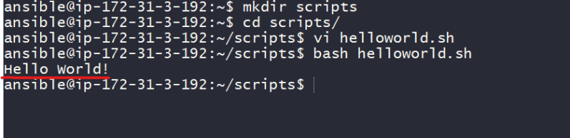
* Generally all the shell scripts will have extensions of **.sh**

What is **#!/bin/bash**?

* + It is called the *shebang*
  + It tells the linux system which binary to use to execute the script
  + For example if you were writing python code the shebang might be **#!/usr/bin/python3**
  + Since we are executing the shell scripts on bash prompt our shebang is **#!/bin/bash**
* To execute the program, we have used *bash* command. If i have a shebang which already tells where the executable is still why do i need bash?
* Remember file permissions in linux (RWX) to execute scripts we need execute permissions, so lets check whats the permission which we have 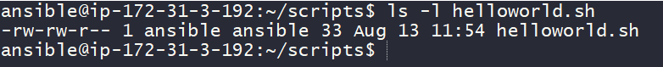
* Now lets add execute permissions and run the script 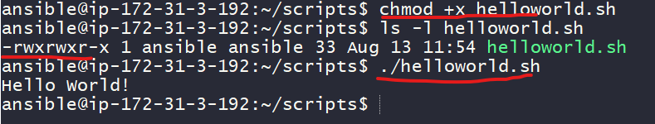

**Readability**

* When writing scripts, aim to make sure the code is as readable as possible.
* How to make scripts readable?
  + Comments
  + Verbosity
* Comments:
  + Comments is nothing more than bit of text explaining what you are doing.
  + In shell the character which we use to denote comments is **#**
  + So lets add comments

Approach 1:

#!/bin/bash

# Print the text to the terminal

echo "Hello World!"

Approach 2:

#!/bin/bash

echo "Hello World!" # Print the text to the terminal

* + Its often a good practice to have script header with fields like
    - Author
    - Version
    - Date
    - Description
    - Usage
  + Script headers and Comments make your scripts more professional 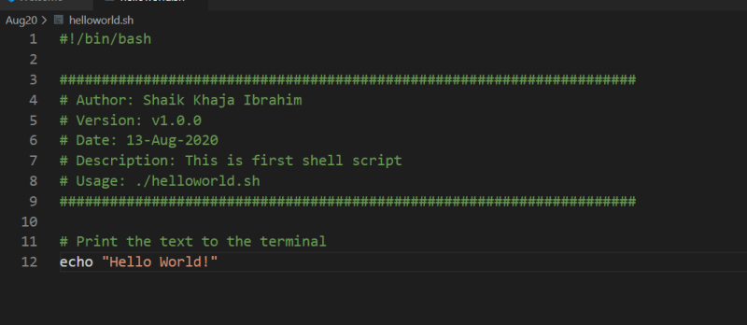

Verbosity:

* + Verbosity is the balancing act between not too much but also not less explanation.
  + Lets discuss three types of verbosity

Verbosity in Comments: Ensure your comments are punctual and smaller.

Verbosity in Commands:

Try to use long variant in commands as shown in the below example with ls -R & ls --recursive. Both give same results but long variant is readable 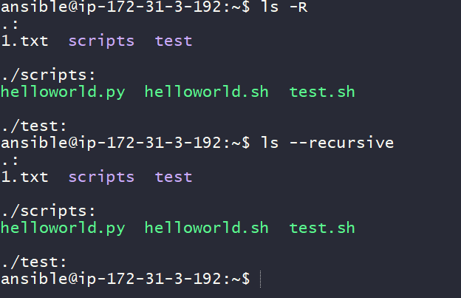

Verbosity in Command Outputs:

Always try to build scripts which take two argument -v/–verbose and -q/–quiet. When user runs your script with verbose parameter give detailed information about what is happening & in other case don’t display anything or display only absolutely required stuff to the terminal.

Shell script is a sequence of linux commands that are to be executed in an order.

Example of verbosity

